Reexam Statistical Learning and Machine Learning 2026
Indholdsfortegnelse
Reexam Statistical Learning and Machine Learning 2026 1
Problem 1 2
Problem 2 3
Problem 3 4
Problem 4. Neural Network 5

Problem 1

Problem 2

Problem 3

Problem 4. Neural Network
Feedforward, the theory behind:
$a_{j}=\sum_{i=1}^{D}{w_{ji}^{\left(1\right)}}x_{i}+w_{j0}^{\left(1\right)} \left(5.2\right)$
$z_{j}=h_{1}\left(a_{j}\right). \left(5.3\right)$
$a_{k}=\sum_{j=1}^{M}{w_{kj}^{\left(2\right)}}z_{j}+w_{k0}^{\left(2\right)} \left(5.4\right)$
$z_{k}=h_{2}\left(a_{k}\right)$
Og $z_{k}=y{\left.​\right|}_{1 layer network}$.
With matrix multiplication I simplify the process of evaluating.
$x ∈R^{Nx1}$
$a^{\left(1\right)}=w^{\left(1\right)}.{\left[b^{\left(1\right)}, x^{T}\right]}^{T} ∈R^{Jx1}$
$a^{\left(2\right)}={\left[b^{\left(2\right)},w^{\left(2\right)}\right]}^{T}.z^{\left(1\right)} ∈R^{Kx1}$
$z_{k}=y_{k} ∈R^{Kx1}$

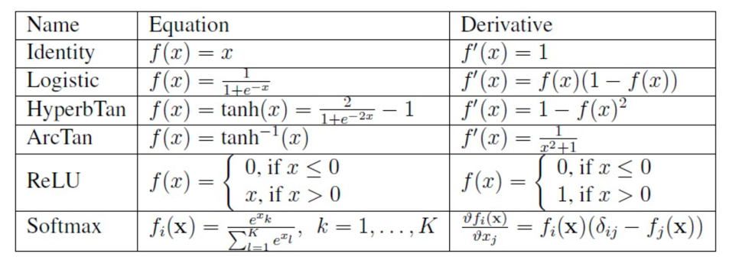
Backpropagation
$δ_{k}=y_{k}-t_{k}$
$δ_{j}=h^{'}\left(a_{1}\right) piecewiseMult \left(w_{2}δ_{k}\right)$
$\frac{∂E}{∂w_{2}}=\left[\begin{aligned}\frac{∂E}{∂w_{0, 1}^{\left(2\right)}} \\ \frac{∂E}{∂w_{1, 1}^{\left(2\right)}} \\ \frac{∂E}{∂w_{2, 1}^{\left(2\right)}} \\ \frac{∂E}{∂w_{3, 1}^{\left(2\right)}} \\ \frac{∂E}{∂w_{4, 1}^{\left(2\right)}}\end{aligned}\right]=z_{1}δ_{k}^{T}$
$\frac{∂E}{∂w_{1}}=\left[\begin{matrix}\begin{matrix}\frac{∂E}{∂w_{0, 1}^{\left(1\right)}} & \frac{∂E}{∂w_{0, 2}^{\left(1\right)}} & \frac{∂E}{∂w_{0, 3}^{\left(1\right)}} \\ \frac{∂E}{∂w_{1, 1}^{\left(1\right)}} & \frac{∂E}{∂w_{1, 2}^{\left(1\right)}} & \frac{∂E}{∂w_{1, 3}^{\left(1\right)}} \\ \frac{∂E}{∂w_{2, 1}^{\left(1\right)}} & \frac{∂E}{∂w_{2, 2}^{\left(1\right)}} & \frac{∂E}{∂w_{2, 3}^{\left(1\right)}}\end{matrix} & \begin{matrix}\frac{∂E}{∂w_{0, 4}^{\left(1\right)}} \\ \frac{∂E}{∂w_{1, 4}^{\left(1\right)}} \\ \frac{∂E}{∂w_{2, 4}^{\left(1\right)}}\end{matrix}\end{matrix}\right]=x_{1}δ_{j}^{T}$
$w^{\left(τ+1\right)}=w^{\left(τ\right)}-η∇E\left(w^{\left(τ\right)}\right) \left(5.41\right)$

